EXP NO 13. Create an Iaas source group in a public cloud environment
Aim:
To demonstrate Infrastructure as a Service (IaaS) by creating a Resource Group using a public cloud service provider (Microsoft Azure) and configuring it for minimal resource usage.

STEP1: CREATE AN ACCOUNT IN MICROSOFT AZURE.
STEP 2: CREATE A NEW RESOURCE GROUP
STEP 3: VERIFY THE RESOURCE GROUP
STEP 4: (OPTIONAL) ADD A RESOURCE
STEP 5: STOP / DELETE RESOURCE GROUP (OPTIONAL) DESIGN:
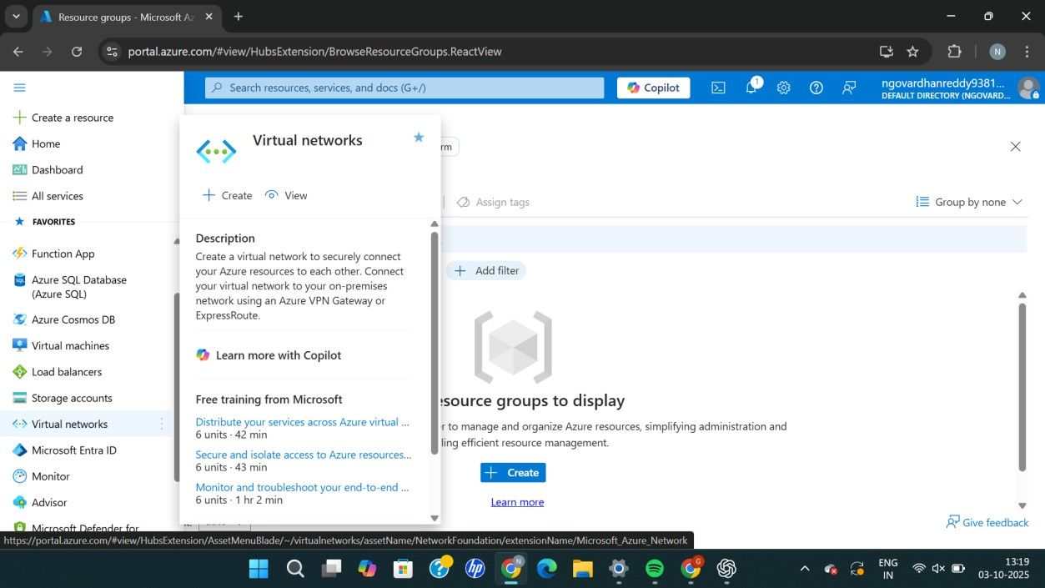
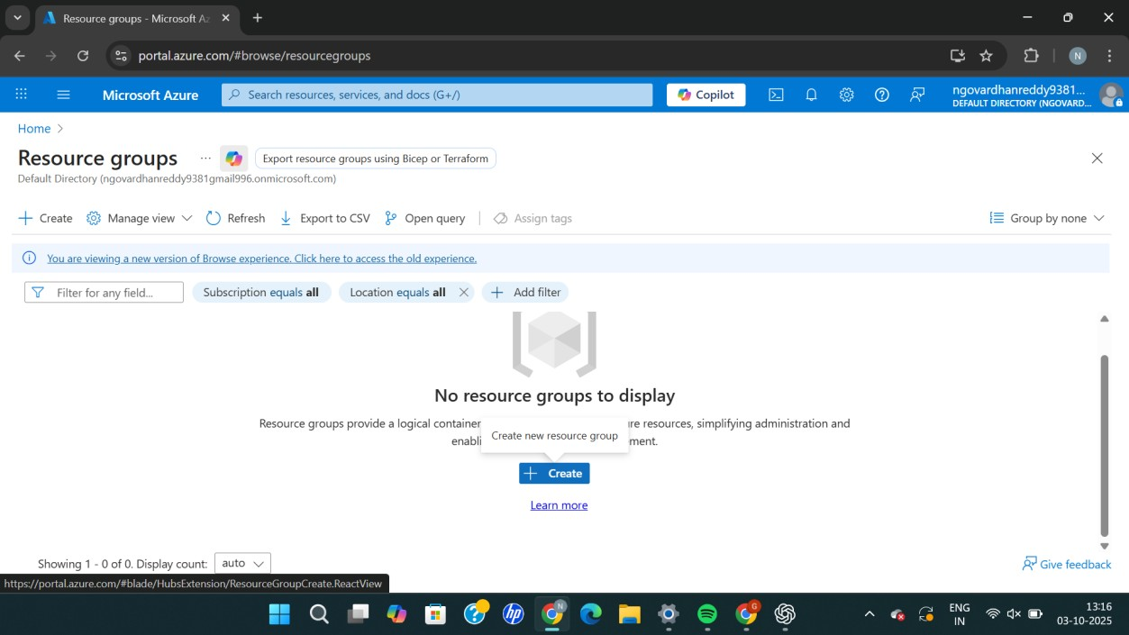

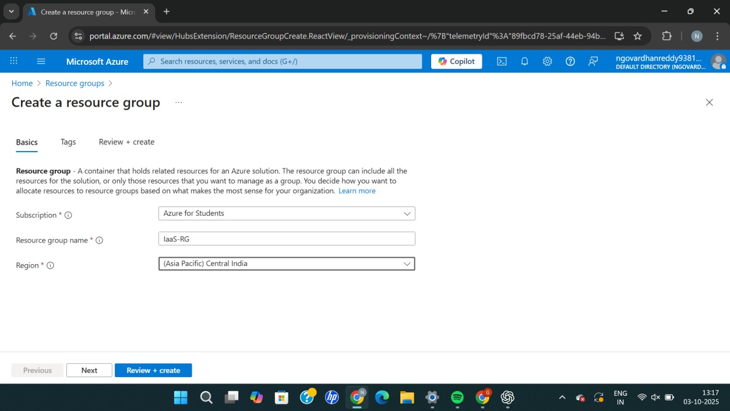
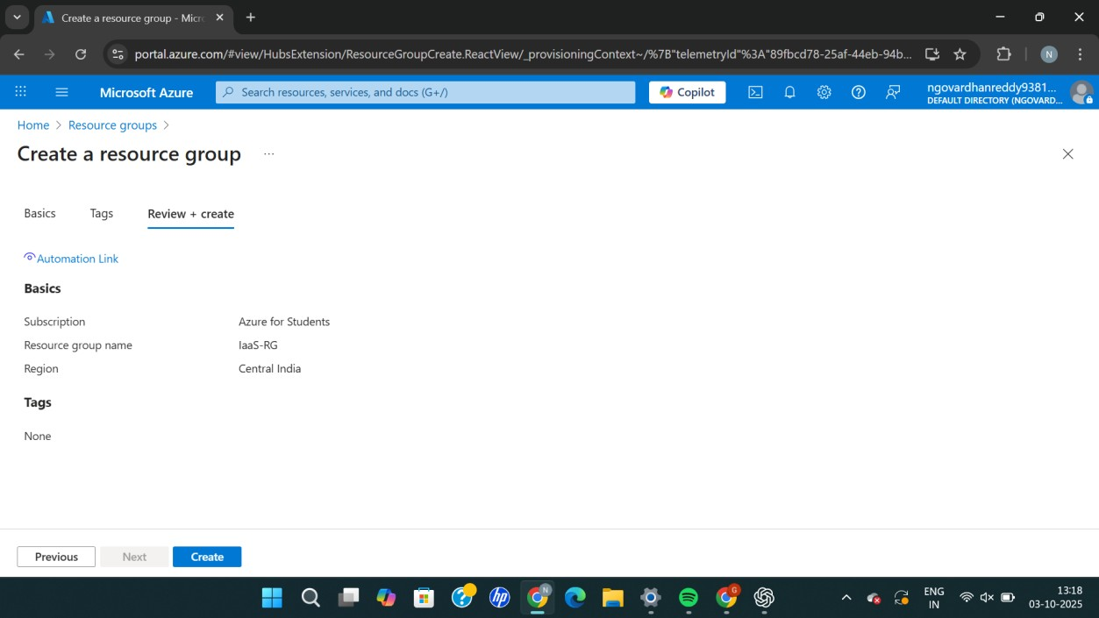
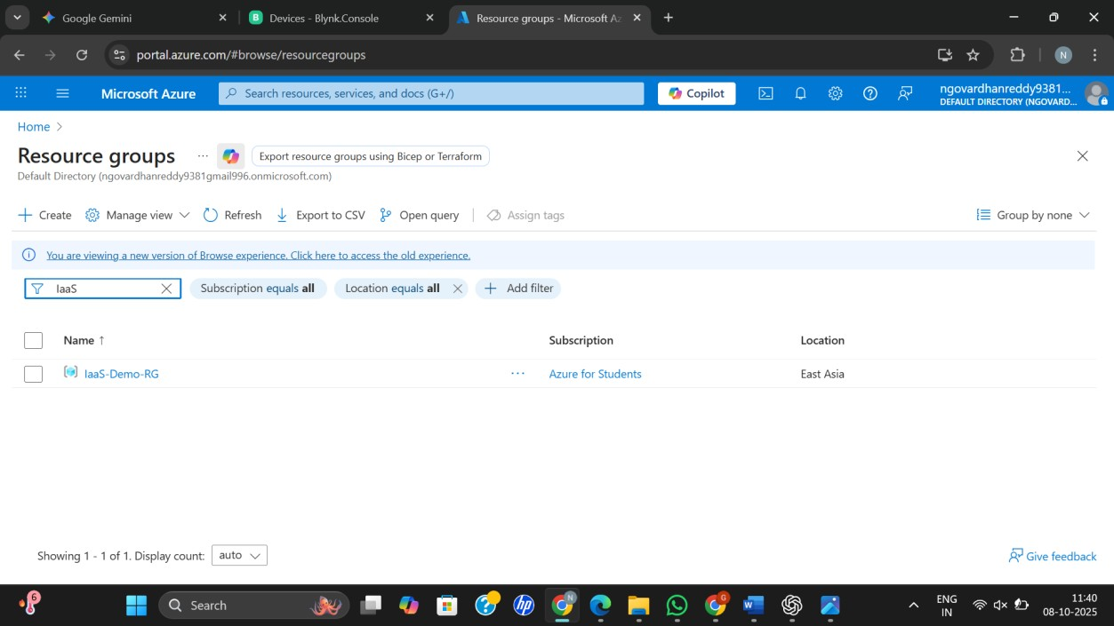
Result:
A Resource Group was successfully created in Microsoft Azure, demonstrating the initial step of Infrastructure as a Service (IaaS) setup.

